KARNATAKA VETERINARY ANIMAL AND FISHERIES SCIENCES UNIVERSITY, BIDAR
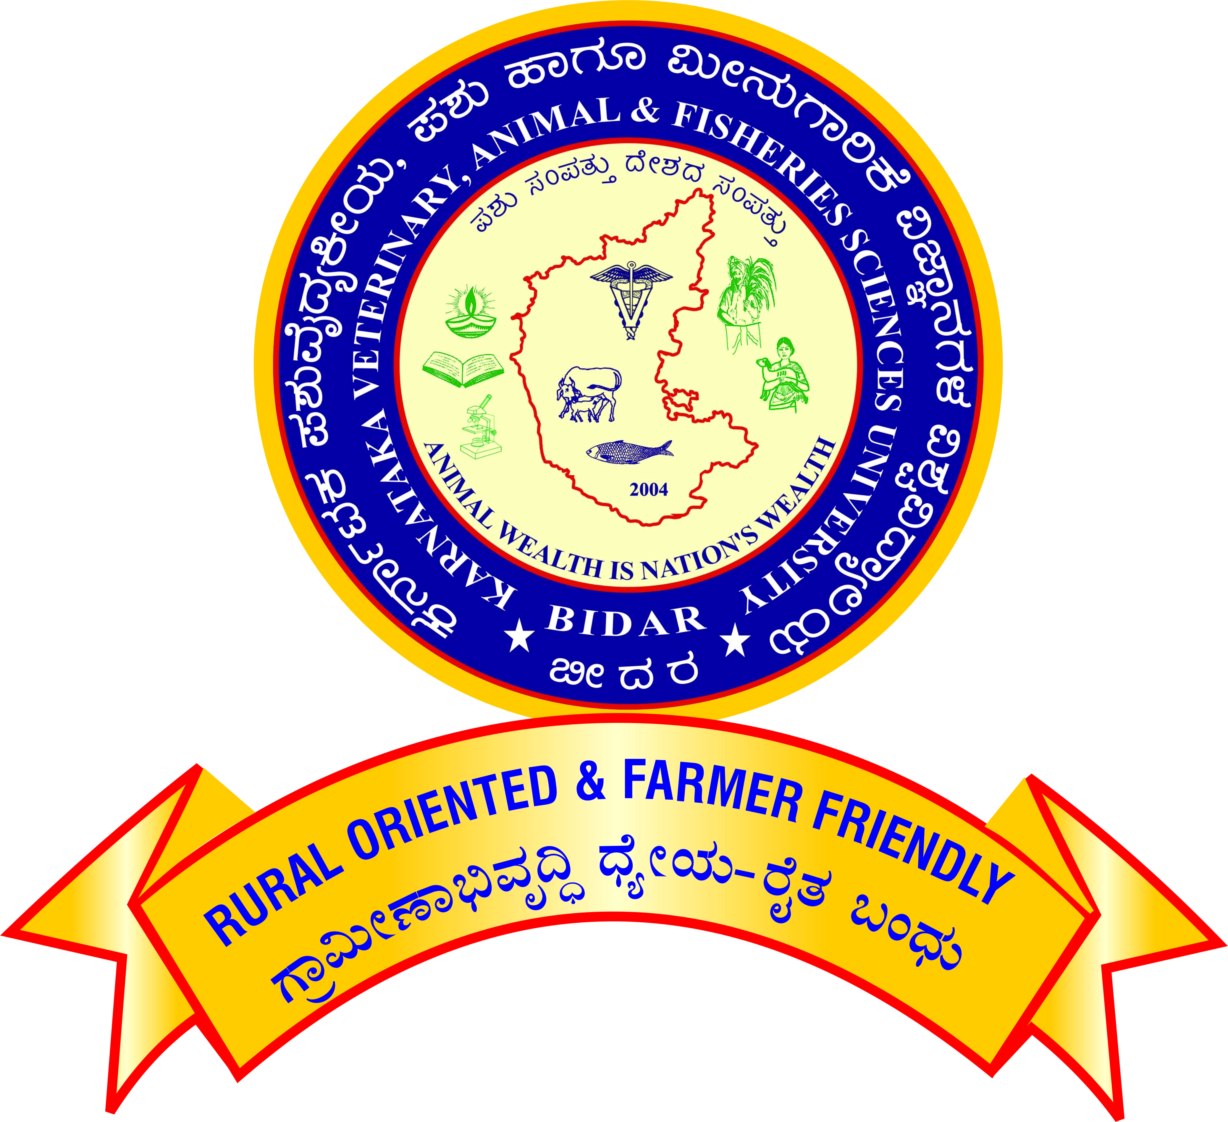

APPLICATION FOR PROMOTION OF TEACHERS UNDER CAREER ADVANCEMENT SCHEME – 2016

For promotion from Professor (Academic Level 14) to Senior Professor (Academic Level 15)

[Note: All the claims shall be supported by relevant letters/certificates issued by concerned dean/controlling officer]
Affix self-attested photo.

1. Name :

2. Designation and Address :

3. Name of the Department/ :

Section/Unit/Scheme

4. Date of Birth :

5. Academic Qualification :

Degree / Diploma | Discipline/  Subject | University/ Board | Month/  Year of passing | Marks/ OGPA  obtained | Remarks

6. Date on which Ph.D. degree Completed :

7.
- Date of joining duty at KVAFSU, BIDAR as Professor in the Academic Level 14/AGP 10000 | :

8. Date of completion of 10 years’ service :
in the cadre of Professor
(Academic Level 14/AGP 10000)

9. Employment record:
- Service within the university

Place of work with full address | Designation / Post held | Scale of Pay | Period |  | Nature of duties
 |  |  | From | To
b. Service outside the university
Place of work with full address | Designation / Post held | Scale of Pay | Period |  | Nature of duties
 |  |  | From | To

10. Eligibility for Promotion
- Have you published a minimum of ten publications in the peer-reviewed journals or ICAR/UGC-listed journals during the assessment period? Yes/No

If yes furnish details as follows and enclose copy of the same
Sr. No. | Authors | Title of the publication | Year | Volume and page numbers
- Whether the PhD/master’s degree has been successfully awarded to two candidates under his/her supervision during the assessment period? Yes/No
If yes furnish the details
S.No | I.D.No. and Name of the Ph.D/Master’s Student guided | Year of award | Specialization

11. Details of Work Performance:

Areas in which the scientist/teacher made some mark including the specific Achievements in teaching/ research/Extension/corporate activities (administration and management) during the assessment period.
A) Teaching:
a). Courses taught.
i) Bachelor level:

Course title | Year & Class | Course No. | Cr.Hrs. | Semester | Independently or Jointly with
Academic Year:

ii) Master level:

Course title | Year & Class | Course No. | Cr.hr | Semester | Independently or Jointly with
Academic Year:

iii) Ph.D. level:

Course title | Year & Class | Course No. | Cr.hr | Semester | Independently or jointly with
Academic Year:

b). Guidance to PG students as Chairman of the Advisory Committee
- Completed Masters Students :
- Completed Ph. D. Students :

c). Guidance to PG students as Member of the Advisory Committee
- Completed Masters Students :
- Completed Ph. D. Students :
B). Research:
- Externally funded projects

Sl.  No | Title | Funding agency | Budget | Year of start | Year of completion | As PI /Co-PI
Note: The Project shall be completed/in operation and Funds must be released.

- Patents / varieties / prototypes / technologies developed / breeder quality seeds production
i) As PI :

ii) As Co-PI :

- Monitoring of the research/extension projects such as RKVY and other GoI/GoK Projects (Other than Externally Funded Projects).

Sl.  No | Title | Funding agency | Budget | Year of start | Year of completion | Involved as

C) Extension:

- Transfer of technologies (farm trails/ :
Field days/ Krishi Melas/ Demonstrations/
Exhibition/ Discussion meeting/ on-farm
Testing/ on campus official consultancy conducted.

- Training programme organized:
- Duration: upto 1 week

i) As Coordinator :
ii) As Associate Coordinator :

Sl No | Title | Duration | Place and Date | Organized by | Coordinator/Associate Coordinator

- Duration: more than one week:

i) As Coordinator :
ii) As Associate Coordinator :

Sl No | Title | Duration | Place and Date | Organized by | Coordinator/Associate Coordinator
- As Resource Person in the training Programme :
Number of Lectures:
Sl No | Place and Date | Type of Event | Title of Training | Topic Discussed | Organized by

- Official Diagnostic visit to farmer’s fields:
/On-farm/ Units/Radio/TV talk/Expert
Service/ Consulting/Visitors extension

- Feedback to research/ Contribution to Package of practices

- Clinics/ Diagnostic/ Farm Work/ Head:
of EEC/ (Other than teaching)

Published work during the assessment period
- Research Publications:
Sl  No | Name of Author(s)  in order | Year | Title of the paper | Name of the journal  (Vol. No., issue no & page no) | NAAS Rating
- Professional Book published/Edited (Minimum of 64 pages-Only with ISBN No.)

- Recognized publishers
- Chapters in standard books
- Research / Extension bulletin

- Research note /communication in a journal / Presentation or abstract in symposium seminar / workshop / training manual /popular article / leaflet proceedings of the workshop

III. Awards/Peer Recognition (During the assessment period)

- Awards from recognized International organizations like FAO, OIE/WoAH, WHO, IDF etc :
- National awards by Govt. Institutions :
- Recognized State awards / University awards :
- Professional society award :
- Other awards by registered organization :
- Peer Recognition (Special assignments (International organizations, overseas and special national assignments / consultancies) :

IV. Corporate Responsibilities / Other activities in the college/university during the assessment period:

V. Professional Responsibilities outside the university

- Working in the executive committee of Professional Bodies/ Societies
.S.No | Name of the Professional body | Involved as | Year and duration
1
2

ii. Working in Board of Management /Academic Council/ Research Advisory Committee of other university/institute:
S.No | Particulars of the assignment | Name of the University/ Institute | Involved as | Year
1
2

iii. Working in the Editorial board of research journals/professional publications
S.No | Name of the journal/Details of publication | Place of publication | Involved as | Year
1
2

iv. Working as Referee/ Reviewer of research journals
S.No | Name of the journal | Place of publication | Number of articles reviewed | Year
1
2

v. Organizing Conference/symposium.
S.No | Name of the conference/symposium | Involved as | Date, Year and Place
1
2
3

vi. Organizing Summer/Winter School
S.No | Name of the Summer/winter school | Sponsoring Agency | Involved as | Date, Year and Place
1
2

vii. Working in National/ State level government committees
S.No | Particulars of the assignment | Committee constituted by | Involved as | Date, Year and Place
1
2

viii. Working in the Expert Panel of ICAR/ASRB/VCI/UPSC/KPSC and other agencies.
S.No | Particulars of the assignment | Panel constituted by | Involved as | Date, Year and Place
1
2

- Any other significant achievement during the assessment period
(with documents)

Signature

Verified that the information provided by the scientist/teacher is correct.

Signature of the  Head of the Department | Signature of the  Controlling Officer

